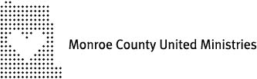
827 W 14th Ct
Bloomington, IN 47404
PHONE: (812) 339-3429
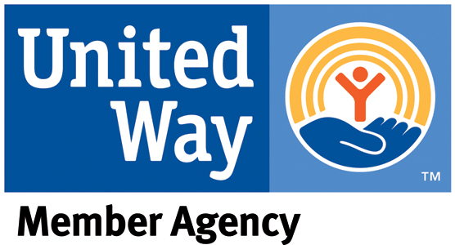
FAX: (812) 339-2912
www.mcum.org

Media Contact: Katie Broadfoot
Development Director
(812) 339-3429 x 18
kbroadfoot@mcum.org
For Immediate Release

Volunteers Needed for MCUM’s “Each One Feed One” Food Drive

Bloomington, IN – June 19, 2019
Monroe County United Ministries (MCUM) will hold its annual “Each One Feed One” community food drive on Friday, August 9 through Sunday, August 11 at grocery stores across Monroe County. Just six months through 2019, our food pantry has fed as many people as it used to in an entire year. This food drive is critical to sustaining MCUM’s food pantry.
MCUM is seeking volunteers to help with this year’s event. Volunteers will collect, deliver, and sort food donations over a three-day period, beginning Friday afternoon (4 – 8pm), continuing on Saturday (10am – 4pm), and concluding on Sunday afternoon (1pm – 4pm). Sign up today at www.mcum.org/eofo. For more information, please contact Katie Broadfoot at 812-339-3429 ext. 18 or kbroadfoot@mcum.org.
MCUM appreciates the support of the grocery stores participating in this drive: Hometown IGA, Wal-Mart, & Kroger stores across Monroe County.

Monroe County United Ministries is a 501(c)(3) nonprofit organization focused on eliminating generational poverty in Monroe County through its two main programs: Compass Early Learning Center and the Self-Sufficiency Center.

# # #

